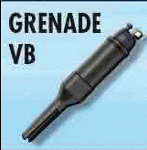
The Trench Cleaners: Grabenfeger versus Trench gun
Patrick Receveur

The New Weapons

1:.1 German Weapon

Submachine Gun BERGMANN MP18
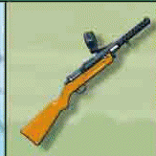
MP18, nicknamed "Grabenfeger" (Trench Cleaner) was the first submachine gun. It would only be put in full operation at the end of war.

❑ Shooting: D6
❑ Range: 3 areas (same as pistol).
❑ D10 For ammunition loss
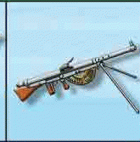
❑ The player can choose to perform 4 simultaneous shots on the same target. He always throws 4D6 and 4D10. There are penalties when firing, throw 4D6 successively (and apply results one after another), then throw the 4D10 for checking for jamming, which occurs on any 0 or 1 on the D10.

Winchester M97
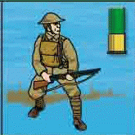
The Doughboys used a version of short cannon which threw knives, called the " Trench Gun ". It was forbidden because his ammunition did not respect the Geneva Convention. Any Doughboy with M97 has an ammunition symbol.

❑ Shooting: D6
❑ Range: 3 areas (same as pistol)
❑ D10 For ammunition loss.
❑ The adjacent areas (if identical, for example only squared or round the same as the target) laterally (not in front or behind but only left or right) to the target suffer a damage power 1.

Rifle Grenade Vivien-Bessières
Put into operation in 1916, the grenade is thrown by a grenade launcher fixed at the end of the gun. The passage of the bullet casts the grenade up to 170 meters. Every French company had 16 of these Grenade Launchers to launch a sustained fire. The Americans were also equipped with it.

Each combatant having a rifle and grenade can use them. In every turn, the combatant can either shoot the gun twice or rifle-grenade once.

❑ Fire using D10, like a grenade (pull the pin then fire) use the grenade dispersion diagram.

❑ No throwback possible
❑ Carried as a rifle
❑ D10 For ammunition use (a cartridge is needed to project the grenade).

Machine Gun CSGR or Chauchat
This French weapon was very well received and remade throughout the war. The Germans did not hesitate to use them when they could find them. The Americans also received 39 000 M1915 (semicircular loader) and 18 000 M1918 (vaulted loader) from France.

❑ Shooting: D6
❑ Range: as for a rifle
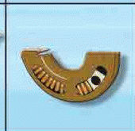
❑ The shooter can perform as much shooting as he wishes until he can’t see any enemies on a straight line of fire or until his weapon gets jammed. At the end of shooting, the Chauchat does not have ammunition left.
❑ To reload the Chauchat, a designated reloader must be adjacent to the Chauchat.
❑ It is impossible to move and to fire the Chauchat in the same turn. The carrier of the Chauchat can only move one area each turn.

 | FIRE TABLE
 | D6 |  | D10
Cases | Pistol  Trench gun  MP 18 | Rifle  Machinegun Chauchat | Flame-thrower | Grenade  Bag of grenades
0 | 4+
1 | 2+ | 2+ | 2+ (5+ if alone) | 5+ or dispersion
2 | 3+ | 3+ | 2+ (5+ if alone) | 5+ or dispersion  Impossible with bag
3 | 4+ | 4+ | 2+ (5+ if alone) | 5+ or dispersion  (if Vivien-Bessières)
4 |  | 5+ | 2+ (5+ if alone) | 5+ or dispersion  (if Vivien-Bessières)
5 |  | 6+
6 + |  | 6+

2 Scenarios

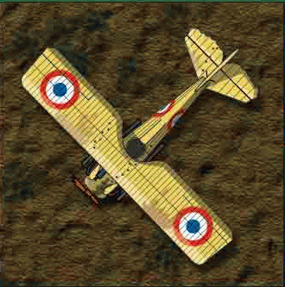
2.0 Placement for all the scenarios

1/The German player puts:
❑ His 10 combatants (green units) in the trench plus a machine gun and MP18 (also in the trench). The machine gun must be more than three areas from both the North and South edges of the map.
❑ All the Surprise marker (without looking at them), with the tree trunks and barb wire must be placed in the area of the trenches and not in numbered areas. The tree trunks must be two areas away from each other. These markers can not stack..

2.1 The First Time

The attacker puts 20 French units (light blue, not trencher cleaners) in a bowl. He pulls from it 10 of the units and also places 2 wire cutter with 2 units on areas containing blue numerical symbols.

Special rules

Turn 2: In the Reinforcement Phase, the attacker places 10 light blue units taken from the bowl (no throw of D10). Afterwards he will use the normal rules with the light blue pawns in the bowl.
Turn 6: The attacker cannot place any more reinforcements in to the bowl.
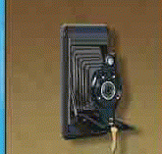
Turn 7: The attacker puts 10 units of Doughboys (American, dark blue) on areas numbered in blue. He allocates them grenades, wire cutters cutters, Chauchat, Chauchat loader, and Grenade Launcher. If the area for placement of a Doughboy is full, bring them on the following reinforcement phase instead.

Victory
+2 each allied (French or American) unit which crosses the no man' s land (exits on area R). Each unit have to go on to Area R and then make a movement off the map. Any allied unit which leaves the map may not return during the game.
+1 per German Unit (+2 if officer or veteran) killed or put out of battle by a French
+2 per German Unit (+3 if officer or veteran) killed or put out of battle by an American
-1 per allied veteran or officer killed (0 in D10)
Result:
14 +: Attacker is declared victor
12 - 13: Draw

2.2 Who Took my Photo?
Set up
The German player puts:
- a plane in any area in front of its trench;
- a rocket launcher on one unit
10 trench cleaner units (blue and red) with all grenades (not bags) are put on the red and blue numbered areas to be chosen by the French player. The attacking French player does not have any reinforcements.

Special rules
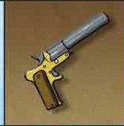
Night: It's dark, it is impossible to fire more than three areas except when a flare rocket is used. The flare rocket can only be used once. It must have the pin pulled and then fired.

“Corps-Francs” (special French units dedicated to close combat actions and commando missions): Trench cleaners are in fact Corps-Francs: they are considered as always having a wire cutter (without the marker) and pistols. They do not have rifles.

Plane: A Corps-Francs marker uses one action and must be in within four areas of the plane and uses the Photographic equipment which it finds (once the photo is taken remove the plane). The plane is never in line of fire.

Victory
To win, a Corps-Francs unit with the camera must go on a blue numbered area and make a movement off the map.
Any other result: German victory

3. Errata for Hand to Hand

4.1 Simultaneous resolution
❑ Both combatants throw 1D10. A wounded combatant throws 2 and keeps the lowest dice.
❑ The combatant having got the lowest score loses.

4.3 Damage in hand to hand
Use the lowest D10 thrown
❑ D10 = 0: he died, withdraw him from game.
❑ Odd: he is Hors de Combat
❑ Even: he is wounded, turn him over

Thanks to
Amaury de Vandière, Arnauld Della Siega, Craig Ambler, Nicolas Favre

